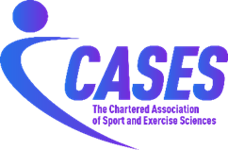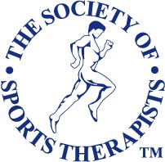

MEMORANDUM OF UNDERSTANDING

A partnership between

The Society of Sports Therapists
and
The Chartered Association of Sport and Exercise Sciences

- Objective

  - This Memorandum of Understanding (MoU) outlines the agreed collaborative relationship between The Society of Sports Therapists (The SST) and the Chartered Association of Sport and Exercise Sciences (CASES) for the purposes of fostering co-operation and mutual benefit towards our respective organisation Visions.

  - Relationship: CASES and The SST wish to develop a mutually respectful relationship that reflects an understanding of each other’s area of remit and expertise and supports practitioners in their field. Both organisations will endeavour to collaborate to further Sport and Exercise Science and Therapy in the UK and globally.

- Background

  - Founded as a not-for-profit organisation in 1990, The Society of Sports Therapists is today the largest lead organisation for Sports Therapists in the UK. Membership of the Society is at Graduate level via a Society accredited degree programme. The Society now collaborates with 36 universities, including two internationally and accredits 45 academic Undergraduate and Postgraduate programmes.

2.2 Through accreditation, membership entry requirements, adherence to the Society’s Code of Conduct, Performance and Ethics, and Standards of Proficiency, insurance and the provision of member support services, The SST ensures that all Graduate Sports Therapists are competent and capable at providing safe practice to their patients and clients. Our overarching aim is to raise the profile, status and standards of Sports Therapists and the profession.

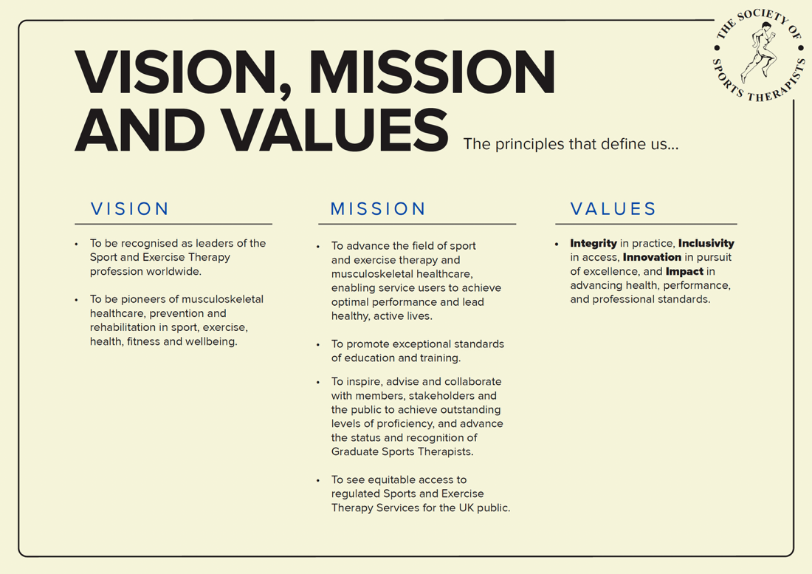
  - CASES (formerly BASES; formerly BASS) was founded in 1984. In May 2024, BASES was granted the Charter of Incorporation by His Majesty King Charles III. On 1 April 2025, BASES was incorporated as The Chartered Association of Sport and Exercise Sciences (CASES). CASES is the professional body and membership association for sport and exercise sciences in the UK. CASES’ mission is to innovate, advance knowledge, promote best practice and advocate the profession by building a collaborative and inclusive sport and exercise science community. CASES has a range of accreditations and endorsements that maintain high standards in sport and exercise science, providing a quality assurance framework for practitioners and laboratories. Per our Royal Charter, CASES’ objects are:

- the promotion of research in sport and exercise sciences;

- the encouragement of evidence-based practice in sport and exercise sciences;

- the distribution of knowledge in sport and exercise sciences;

- the development and maintenance of high professional standards for those
involved in sport and exercise sciences, and;

- the representation of the interests of sport and exercise sciences nationally and internationally.

- Collaboration

3.1 The parties will seek to actively collaborate on areas of mutual benefit, promote aims and encourage cross-collaboration from their respective communities of interest. This may include areas such as:

- collaboration on the development of member content and research such as guest/joint articles and editions of publications,

- dissemination of research findings and promotion of other relevant content, conferences and events,

- joint webinars and events, with CASES and SST members access at reciprocal member costs where applicable.

- content/course accreditation and endorsement, including a Chartered Scientist/ CASES member case study/profile on The SST website and a Graduate Sports Therapist (MSST) included within the CASES Careers guide,

- social media reciprocation (like/share/comment/post).

  - Whilst the list above is indicative of the areas for potential collaboration, under the terms of this MoU the parties will commit to:

- celebrate the signing of this MoU via social media and their membership communities’

- a joint webinar to highlight the tangible value of the partnership (with details to be confirmed)

- exchange logos and share the background information about each other on their websites.

4. Review

  - Both parties commit to at least one partnership review meeting per year. Within these meetings, the review of existing partnership arrangements will take place, as well as examining scope for further expansion of the partnership.

  - The MoU can be amended at any point by unanimous agreement.

5. Confidentiality

  - Both parties commit to complying with any applicable privacy legislation in their jurisdiction regarding any personal information they receive about the members of the partner organisation. This provision will survive termination of this MoU.

  - Both parties agree not to disclose any information or documents which comes to its knowledge or into its possession by reason of this MoU which the other partner organisation has explicitly or implicitly indicated as confidential unless otherwise pursuant to judicial or legislative authority in the respective jurisdiction. This provision will survive termination of this MoU.
- Term

6.1 This MoU becomes effective from the date that the representatives of the participating parties sign this agreement below. The intention is for the agreement to continue for three years, with an annual review. At the end of the term, the MoU may be extended by the mutual written agreement of the parties.

6.2 This MoU may be revised through the mutual agreement of the parties and may be terminated by either partner upon giving six months’ written notice signed by the recognised Chief Executive Officer of the notifying party.

For The SST | For CASES
Name: Simon Bowen | Name: Ian Wilson
Post: Chief Executive Officer | Post: Chief Executive Officer
Date: 15 April 2026 | Date: 21 April 2026

